Image | 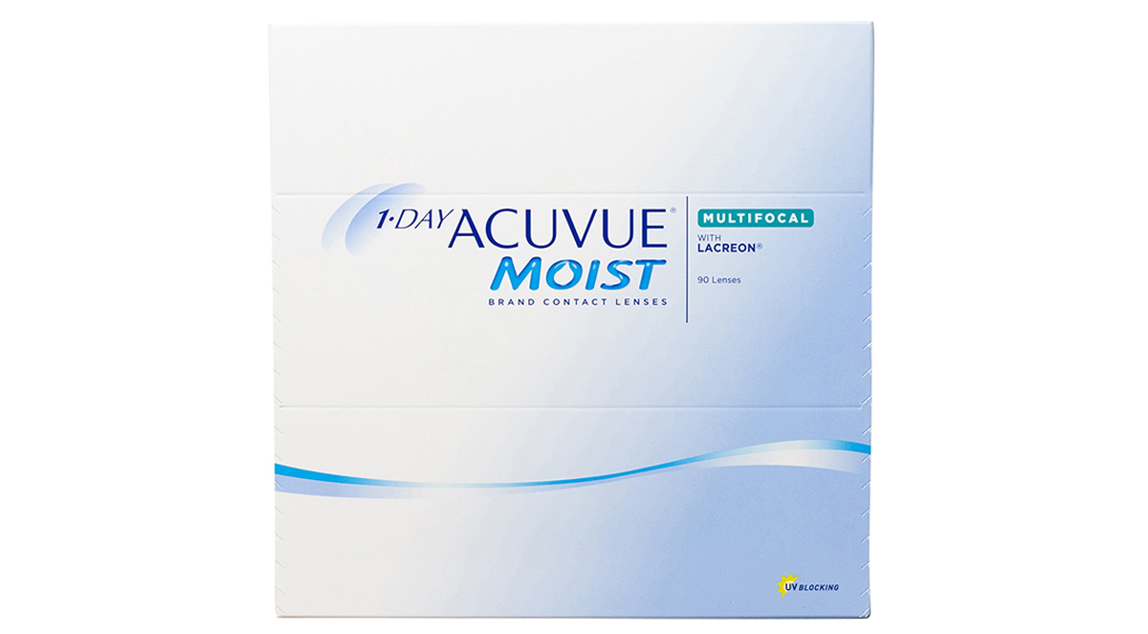
Brand | GUCCI
Model Name | 1-day-acuvue-moist-multifocal8
Price | RS 1800
PRODUCT DETAILS

